Energy crisis in Europe revamps the economic competitiveness of green chemicals
Abhinandan Nabera, Ioan-Robert Istrate, Antonio José Martín, Javier Pérez-Ramírez* and Gonzalo Guillén-Gosálbez*
Institute for Chemical and Bioengineering, Department of Chemistry and Applied Biosciences, ETH Zürich, Vladimir-Prelog-Weg 1, Zürich 8093, Switzerland
*Corresponding authors: jpr@chem.ethz.ch; gonzalo.guillen.gosalbez@chem.ethz.ch

Abstract
Ammonia and methanol are versatile platform chemicals heavily relying on natural gas, resulting in vulnerability to supply disruption and a large share of CO₂ emissions. Extensive research has been conducted to identify low-carbon production routes, but the relatively higher costs act as a bottleneck. Here, we show how an unprecedented crisis of soaring energy prices in Europe, triggered by a lower offer of natural gas in the market, may have radically changed this situation, equalising the economic competitiveness of fossil- and green-based routes. Green ammonia generated by wind electrolysis has been competing with its fossil fuel equivalent for six months as of December 2021. Similarly, methanol produced by capturing CO₂ and using hydrogen generated from wind energy is economically appealing, particularly during the peak of natural gas prices in August 2022. These events represent Europe's chance to lead the renewable transition in the chemical industry upon a joint action of the academy, industry, and policymakers.

Introduction
The chemical industry is the industrial sector with the highest energy demand due to its reliance on fossil fuels. About 14% and 8% of global oil and gas, respectively, are consumed by the chemical industry¹, which is also responsible for 5.6 Gt CO₂-eq yr⁻¹ (including direct and indirect emissions), equivalent to roughly 10% of global anthropogenic greenhouse gas (GHG) emissions^{2,3}. Ammonia and methanol are primary building blocks of the chemical industry, used as raw materials for the production of valuable products with a wide range of applications. Ammonia, in particular, is critical for nitrogen fertilisers, which are essential to ensure global food security^{4,5}. Similarly, methanol is a building block for the manufacture of formic acid, acetic acid, dimethyl ether, and methylamine and serves as an intermediate to olefins and aromatics production^{1,6}.
Presently, ammonia and methanol production are based on syngas (a mixture of CO and H₂), primarily obtained from steam reforming of natural gas. Hydrogen is combined with nitrogen typically over an Fe-based catalyst to produce ammonia via the energy-intensive Haber-Bosch process at high pressure and temperature (>200 bar and >400 °C)⁷. About 70% of the global ammonia production uses natural gas, absorbing about 20% of the industrial demand and releasing ca. 0.5 Gt CO₂-eq yr⁻¹ over the life cycle (9.3% of the chemical sector’s emissions)⁸. The standard process for methanol production requires hydrogenation of CO at high pressure and relatively mild temperature (>35 bar and >200 °C) over a Cu-Zn-Al catalyst⁹. Like ammonia, 65% of global methanol relies on natural gas¹⁰, while life cycle GHG emissions are around 0.3 Gt CO₂-eq yr⁻¹ (5.4% of the chemical sector’s emissions)¹⁰.
Low-carbon ammonia production could be realised by running the Haber-Bosch process with hydrogen from water electrolysis powered by renewable energy sources like wind or solar (green Haber-Bosch)^{8,11}. This hybrid electro-thermocatalytic scheme is under intense development and has been claimed to be the first implementable low-carbon alternative¹². While a longer-term option, such as direct electrocatalytic reduction of nitrogen at large or small scale, is highly desirable because of its association with renewable electricity sources, it is still impractical to implement at an industrial scale. As for methanol, the required conversion of CO₂ into CO via the reverse water gas shift reaction is a highly optimised technology. Nevertheless, recent breakthrough discoveries of catalytic materials such as promoted indium oxide^{13,14} or zinc-zirconium oxide¹⁵ have directly opened the door to hydrogenate CO₂ into methanol. These catalytic technologies, in combination with carbon capture and production of low-carbon hydrogen¹⁰, can sustain a greener methanol production. Regarding the electrocatalytic route, methanol remains a minor product in the direct conversion of CO₂ and has thus not yet signalled promise for upscaling¹⁶.
Overall, prior works have demonstrated the technical feasibility^{8,11,17,18} and potential climate benefits^{19–22} of developed low-carbon chemical production options. However, the common denominator is the production costs at least doubling those attainable by fossil-based routes^{19,23,24}. Natural gas has experienced a sharp price increase over the last two years, primarily due to the skyrocketing inflation following the COVID-19 pandemic and the global energy crisis caused by the Russian invasion of Ukraine. Energy supply disruption has severely affected Europe, where monthly average natural gas spot prices have increased from 0.6 USD kg⁻¹ in July 2021 to 2.3 USD kg⁻¹ as of July 2022²⁵. This drastic change is a severe threat to the European chemical industry, wherein one such instance, more than half of Europe’s ammonia production capacity (around 8% of the global production)¹¹ was halted in 2022^{26,27}. Nevertheless, looking from a different perspective, this unforeseen event could provide an opportunity to improve the economic competitiveness of green ammonia and methanol while accelerating the renewable transition. It is still to be determined whether green chemicals exhibit economic supremacy in addition to their environmental dominance in the current situation.
We address this critical research gap by estimating Europe's production costs for fossil and green ammonia and methanol by applying techno-economic assessments considering the monthly fluctuation in energy prices. For ammonia production, we investigate the Haber-Bosch process considering four typical hydrogen sources¹¹: i) grey hydrogen from steam methane reforming (SMR) using natural gas, ii) blue hydrogen from SMR coupled with carbon capture and storage (CCS), iii) green hydrogen from water electrolysis using solar photovoltaic (PV) electricity, and iv) green hydrogen from water electrolysis using on-shore wind electricity. Similarly, we compare four alternative production routes for methanol: i) conventional synthesis from natural gas, ii) synthesis from captured CO₂ and blue hydrogen –SMR coupled with CCS–, iii) synthesis from captured CO₂ and solar PV-based electrolytic hydrogen, and iv) synthesis from captured CO₂ and wind-based electrolytic hydrogen. In all cases, we consider that CO₂ is captured from the atmosphere by direct air capture (DAC) to reduce GHG emissions with a reduced risk of burden shifting²⁰. Additional information regarding production routes can be found in section xx of the ESI.

Results

Rising natural gas prices drive up production costs for fossil ammonia and methanol in Europe
Considering the natural gas spot prices in Europe, the production cost (estimated via techno-economic models) for fossil ammonia increased from an average of 0.4 USD kg⁻¹ in the period 2019-2020 to 1.3 USD kg⁻¹ as of November 2022 (Fig. 1a). Similarly, the cost of fossil methanol reached 1.2 USD kg⁻¹ in November 2022, compared with 0.2 USD kg⁻¹ in the period 2019-2020 (Fig. 1b). Natural gas prices and chemical production costs have increased steadily since 2020 due to the rising inflation as a consequence of the COVID-19 pandemic. Since February 2022, after the Russian invasion of Ukraine, natural gas prices have fluctuated considerably, and so have the production costs. For example, ammonia production cost ranges from 1.1 USD kg⁻¹ in February 2022 to 2.4 USD kg⁻¹ in August 2022 (peak of natural gas prices). Overall, compared to July 2021, the estimated production cost for fossil ammonia and methanol rose by 102% and 146% in November 2022, assuming the production process would consume the natural gas sold in the European market at its current price.
Here we assume the natural gas spot prices at the Netherlands’ Title Transfer Facility (TTF) trading hub. The Dutch TTF hub has gained significant importance due to its high trade volumes and currently acts as a European and global benchmark for natural gas prices²⁸. We acknowledge that companies with ongoing long-term contracts may secure a more favourable gas price than the current spot price, and the production cost would also be lower. Yet, the extent to which ongoing contracts have been affected by the energy crisis remains unknown, mainly because of confidentiality clauses. Consequently, we validated our estimated production costs by comparing them against actual market prices during a period of stability before a market disruption in 2022. In this regard, our estimates align well with ammonia market prices from July 2019 to July 2022 (Fig. xx of the ESI) and methanol market prices over the period from January 2015 and November 2022 (Fig. xx of the ESI).
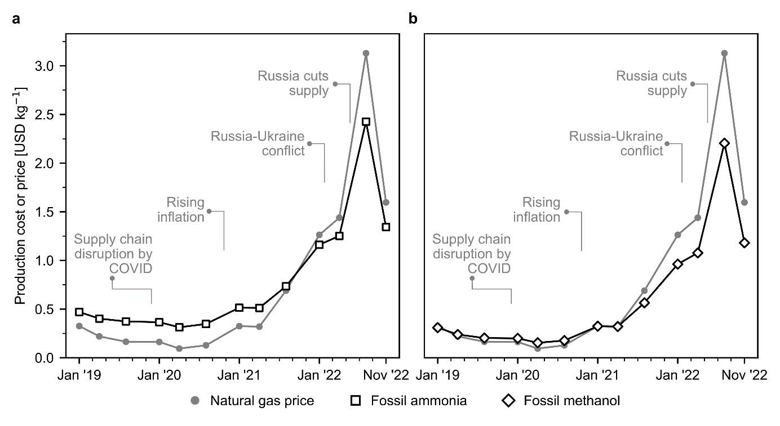
Fig. 1. Natural gas spot prices and production cost for fossil ammonia and methanol in Europe. (a) Fossil ammonia produced via the Haber-Bosch process with grey hydrogen as feedstock. (b) Fossil methanol synthesised from natural gas. Process simulations contain the necessary information for economic calculations (CAPEX and OPEX). Calculations were performed considering the effect of inflation and the monthly fluctuations in natural gas and electricity prices (the evolution of electricity prices in Europe is displayed in Fig. xx of the ESI).

Green vs. fossil: the battle for cost-competitiveness in ammonia and methanol production routes
We subsequently investigate the economic competitiveness of alternative production routes for ammonia and methanol, assuming a hydrogen cost linked to the specific technology deployed and a CO₂ price from DAC. Ammonia production with blue hydrogen follows the same pattern as fossil ammonia, being slightly more expensive due to the additional cost of CCS (Fig. 2a). On the other hand, green ammonia via solar PV-based electrolytic hydrogen became competitive around the peak of natural gas prices in August 2022 (Fig. 2b). In comparison, ammonia produced with hydrogen from water electrolysis using on-shore wind electricity turns economically appealing at natural gas prices of around 1.7 USD kg⁻¹ (Fig. 2c). This is due to the lower cost of hydrogen from wind-based electrolysis, which shows a higher capacity factor compared to solar PV (16.1 to 17.5%, for solar PV, vs. 35.6% to 39% for wind)²⁹. Hence, wind-based ammonia became cost-competitive from December 2021 to October 2022 for six months (Fig. 2c), with production costs ranging from 1.3 to 1.6 USD kg⁻¹ ammonia.
For the case of methanol production from DAC CO₂ and blue hydrogen, the cost of production was, on average, 182% higher than fossil methanol due to the additional cost of CCS and captured CO₂ (Fig. 2d). Similarly, the solar PV-based route never became appealing (Fig. 2e). However, green methanol produced with wind-based electrolytic hydrogen and DAC CO₂ becomes competitive at natural gas prices of around 3.1 USD kg⁻¹ (Fig. 2d), with the break-even natural gas price largely depending again on the levelised cost of hydrogen. Thus, methanol production via this route became cost competitive only at the peak of natural gas prices in August 2022.
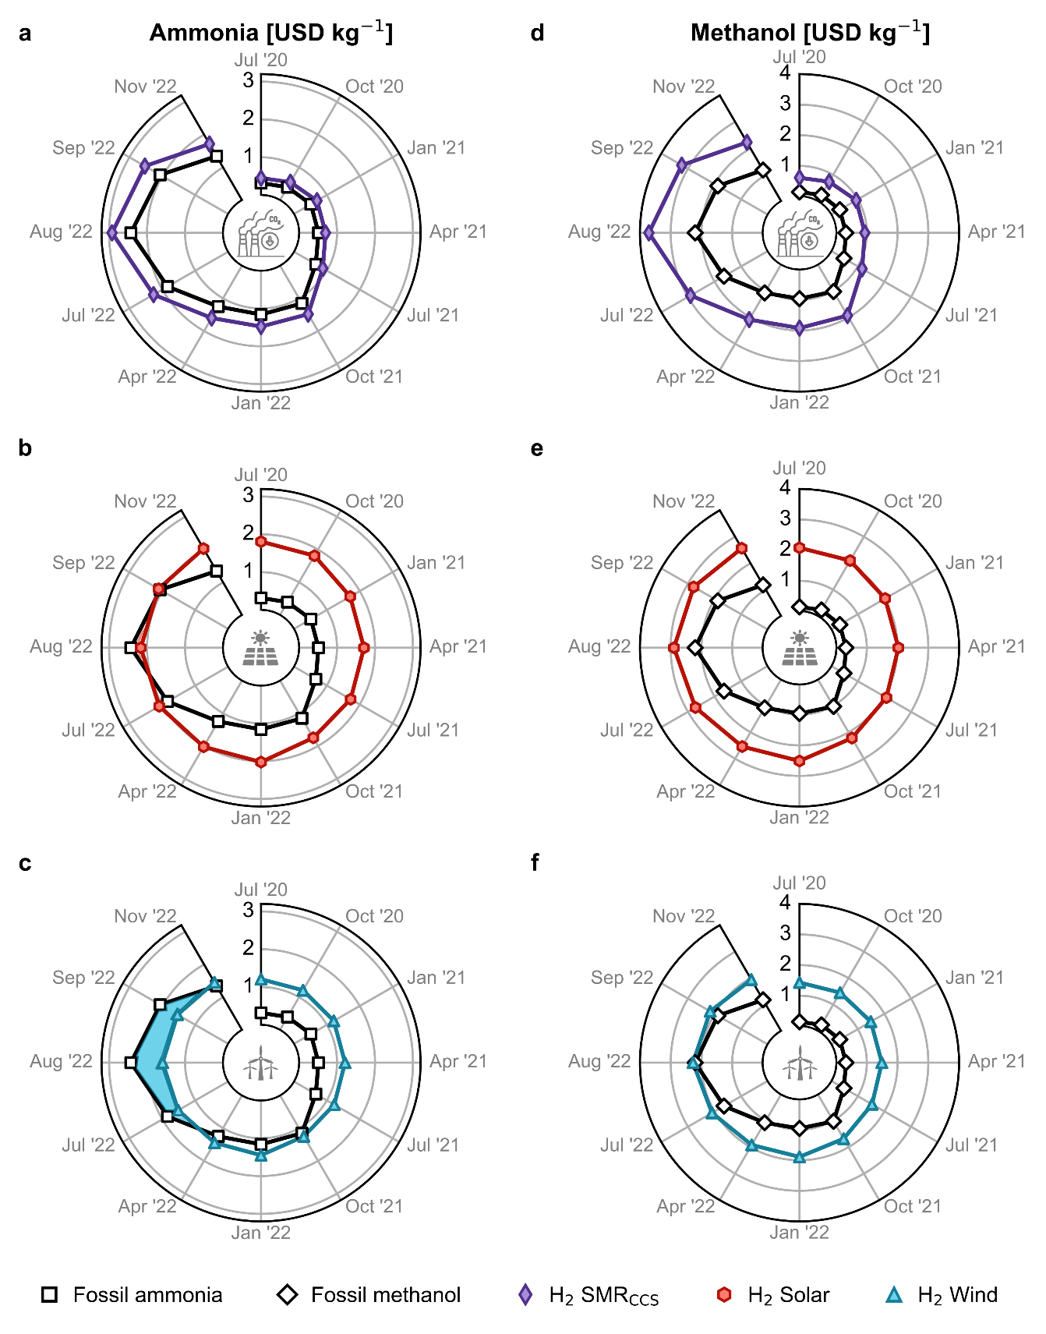
Fig. 2. Production cost for green ammonia and methanol in Europe compared with the fossil counterpart in USD kg⁻¹. Green ammonia produced via the Haber-Bosch process with (a) blue hydrogen from steam methane reforming (SMR) coupled with carbon capture and storage (CCS) and green hydrogen from water electrolysis using (b) solar photovoltaic (PV) electricity or (c) on-shore wind electricity. Methanol synthesised from captured CO₂ and (d) blue hydrogen –SMR coupled with CCS–, (e) PV-based electrolytic hydrogen or (f) wind-based electrolytic hydrogen. Refer to Fig. xx of the ESI to view the complete time range, which covers both the lower and upper bounds for the levelized cost of hydrogen.
We next analyse the breakdown of the production cost for fossil and green chemicals at different time points (Fig. 3). We focus on the green routes based on wind-based electrolytic hydrogen, as these were found to be the most promising routes (results for the other green routes are displayed in Fig. xx of the ESI).
Our results show that the contribution of natural gas to the production cost for fossil ammonia increased from 21% in 2020 to 44% in July 2021 and up to 63% in November 2022 (Fig. 3a). Similarly, for the production of fossil methanol, the share of natural gas increased from 48% in 2020 to 76% in July 2021 and 88% in November 2022 (Fig. 3b). For the green routes, hydrogen represents the highest share of the production cost; up to 69-85% for green ammonia and 61-67% for green methanol, depending on the time point. We estimate that the average European levelised cost of wind-based electrolytic hydrogen has decreased steadily from 5.2-8.5 USD kg⁻¹ in 2019 to 4.5-6.3 USD kg⁻¹ by 2021, primarily driven by a reduction in the cost of on-shore wind electricity from 67 to 42 USD MWh⁻¹, based on ref.²⁹. The hydrogen cost slightly increased in 2022 up to 5.2-7.3 USD kg⁻¹, due to the effect of inflation. Hence, the hydrogen cost applied in this work aligns well with the lower bound of previous literature estimates (i.e., between 4.6 and 10 USD kg⁻¹ based on ref.³⁰).
For green methanol, the CO₂ feedstock captured from the atmosphere by DAC accounted for about 16% of the production cost in 2020 and up to 28% in November 2022. The higher contribution can be attributed to the increased cost of DAC, from an average of 0.2 USD kg⁻¹ CO₂ in 2019 to 0.4 USD kg⁻¹ CO₂ in 2021, reaching the maximum value of 0.8 USD kg⁻¹ CO₂ in August 2022. Here, we consider a high-temperature solvent-based DAC technology, adapted from the work by Keith et al.³¹. This technology requires around 0.1 kg of natural gas and 77 kWh of electricity per kg of CO₂ captured³¹. Hence, the capture cost is susceptible to natural gas and electricity price fluctuations (Fig. xx of the ESI).

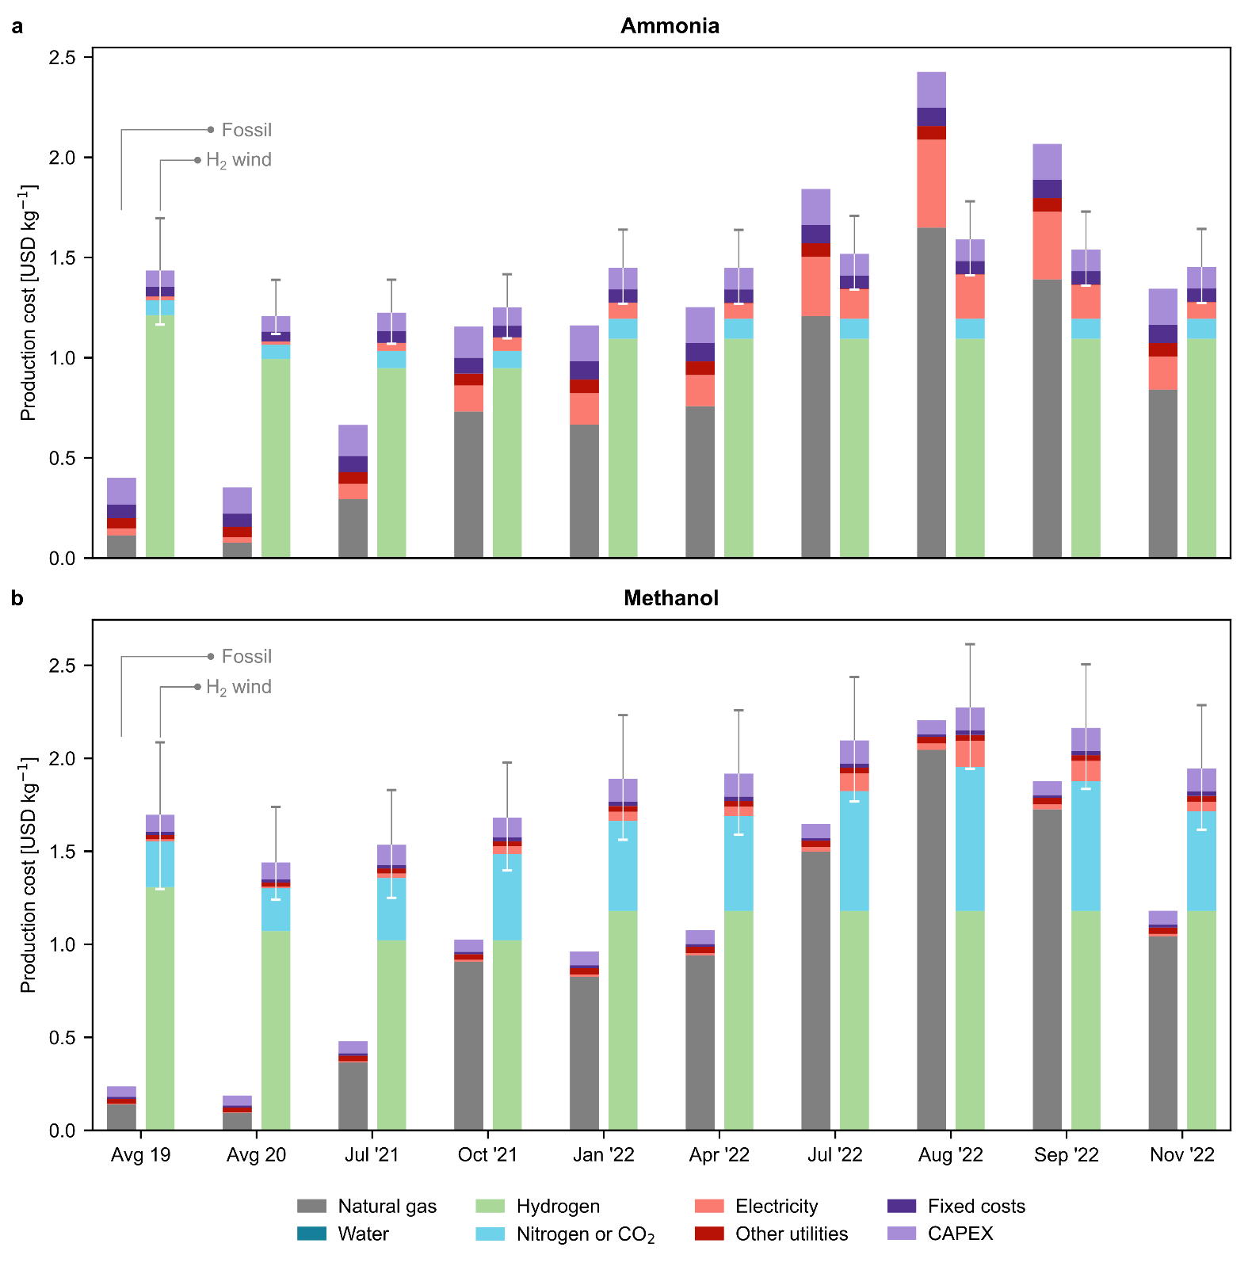
Fig. 3. Breakdown of production costs for fossil and green (a) ammonia and (b) methanol in USD kg⁻¹. Only the green production routes based on hydrogen from water electrolysis using on-shore wind electricity are displayed. These were the most promising routes (the results for other green routes can be found in Fig. xx of the ESI). Error bars indicate the production cost considering the lower and upper bound for the levelised cost of hydrogen (Table xx of the ESI). Average values for the years 2019 and 2020 are employed as the natural gas and electricity prices before July 2021 were almost constant.

The economic tipping point: when green ammonia and methanol became a competitive solution for CO₂ mitigation
We finally analyse the CO₂ avoidance cost of green ammonia and methanol, i.e., the cost per unit of CO₂ avoided due to the substitution of the fossil-based routes with their green counterparts. In 2020 at an average natural gas price of 0.1 USD kg⁻¹, wind- and solar-based ammonia resulted in an avoidance cost of 0.6 and 1.4 USD kg⁻¹ CO₂-eq, respectively (Fig. 4a). This cost was substantially higher for methanol, i.e., 1.4 and 7.7 USD kg⁻¹ CO₂-eq, respectively (Fig. 4b) in the same period, primarily due to the broader monetary gap between fossil and green methanol. Hence, the avoidance cost of green ammonia and methanol in 2020 was way above the removal cost of bioenergy with carbon capture and storage (BECCS) and DAC with carbon capture and storage (DACCS), two of the most prominent negative emissions technologies (NETs), forecasted at 0.1-0.2 USD kg⁻¹ CO₂ and 0.1-0.3 USD kg⁻¹ CO₂, respectively³². However, at the peak of natural gas prices in 2022, the avoidance cost of green ammonia and methanol became negative, implying that mitigating carbon emissions via green ammonia and methanol became appealing. Specifically, the win-win scenario (economic and environmental competitiveness) emerged in July 2021, reaching potential savings of 0.1 to 0.6 USD kg⁻¹ CO₂-eq avoided via the wind-based route for ammonia production, and in August 2022 for methanol via wind, with savings of 0.3 USD kg⁻¹ CO₂-eq avoided if considering the lower end of the hydrogen cost range.
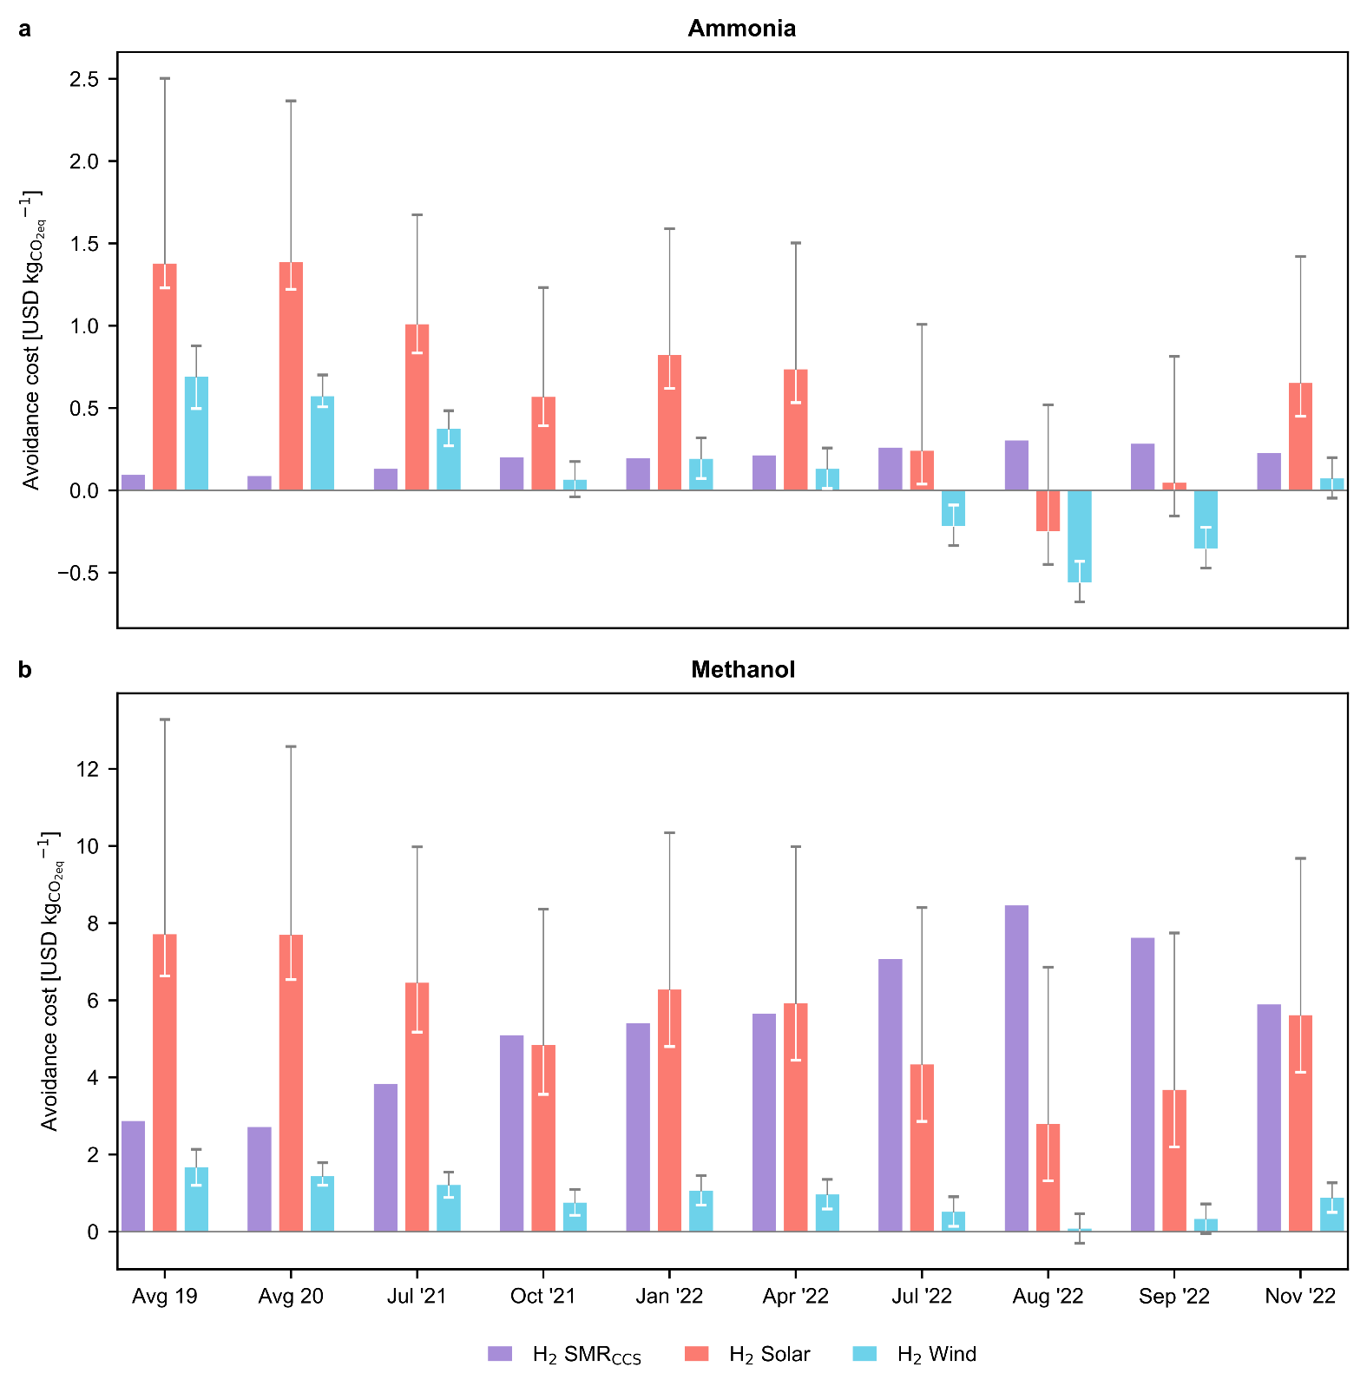
Fig. 4. Avoidance costs for green (a) ammonia and (b) methanol production routes in USD kg⁻¹ CO₂-eq. Error bars display the production cost considering the lower and upper bound for the levelised cost of hydrogen (Table xx of the ESI). A negative avoidance cost means that costs and greenhouse gas (GHG) emissions could be reduced simultaneously.

Discussion
Here we show how an unprecedented crisis of soaring energy prices in Europe could radically change the current landscape of low-carbon chemicals. In 2023, considering zero supply from Russia, unpredictable weather conditions, and increasing competition for liquified natural gas, securing gas supplies could be an obstacle³³. At the same time, the costs of renewable technologies are expected to decline due to technological advancements and the experience effect³⁴. It is estimated that the levelised cost of on-shore wind electricity will reduce from an average of 67 USD MWh⁻¹ in 2019 to 40 USD MWh⁻¹ by 2030, thereby reducing the levelised cost of hydrogen from 5.2-8.5 USD kg⁻¹ in 2019 to around 2.7 USD kg⁻¹ by 2030³⁵.
Production costs of chemicals have been historically higher in Europe than in other regions, primarily due to higher labour and feedstock costs³⁶. The disruption of the global energy market has further exacerbated this gap²⁵. For instance, between 2020 and 2022, the natural gas price increased by a factor of 1.6 in the U.S. compared to 9.6 in Europe²⁵. Within this context, the chemical industry may shift production to lower-cost regions instead of deploying domestic green production routes. However, such relocation can have detrimental socio-economic implications and will likely weaken Europe’s leading role in chemical production while exposing it to the vulnerability of supply disruption. Moreover, chemical companies generate about 1.2 million jobs across the continent³⁷, which would face an uncertain scenario.
In accordance with the Paris Climate Accords, Europe has set targets to reduce emissions by 55% by 2030 and become a net-zero GHG emitting continent by 2050³⁸. It needs to invest majorly in low‑carbon infrastructure to achieve these ambitious targets. A recent study found that the current pace of investment and development is insufficient to meet the targets³⁹. An additional investment of approximately 94 billion USD yr⁻¹ is required in the immediate future until 2025 to achieve net zero. Notably, a tremendous investment increase is needed for renewable power, especially solar (7.6 billion USD yr⁻¹) and on-shore wind (17.3 billion USD yr⁻¹)³⁹. Thus, producing green ammonia and methanol driven by market forces could help the European chemical industry curb GHG emissions at a negative mitigation cost, in contrast to expensive NETs facing socio-political challenges.
A longer-term advantage will be gained if a fraction of this decisive investment is channelled toward research and development, boosting performance of water electrolysis -as a key element of green Haber-Bosch-, direct N₂ electroreduction, and direct CO₂ hydrogenation. All these technologies have potential for mid- to large efficiency enhancement upon overcoming some key limitations related to catalyst design. The technological maturity of water electrolysers will be displayed by lower cell voltages mainly arising from optimized anodes, ideally containing catalysts with lower Pt-group metal content^{40,41}. A step behind in terms of development, the electrocatalytic reduction of N₂ still faces early challenges such as identifying reference catalysts able to simultaneously provide promising activity, stability, and selectivity towards ammonia. As for methanol synthesis, an active challenge on CO₂ hydrogenation is enhanced catalyst activity while attaining further progress in stability and selectivity⁴². Importantly, the availability of different and mature routes could realise a new scenario where green centralised (large scale) and decentralised (small scale) production units exist. This possibility is especially appealing for those chemicals, like ammonia, with potential for direct use. For example, small electrocatalytic reactors coupled to solar power, recently coined as ammonia leaves⁴³, may open the door to direct production of fertilisers at croplands. Such an innovative scheme could be replicated for other products such as ethanol obtained from CO₂ and might contribute to optimize the future model of the chemical industry.
Our findings suggest that rising energy prices in Europe can make green ammonia and methanol production routes cost-competitive, thereby overcoming the primary barrier to their implementation. The current scenario represents a unique opportunity for the European chemical industry to shift to renewable feedstocks to reduce costs and GHG emissions simultaneously and further reduce its dependence on imports and vulnerability to market shocks.

Methods
Economic assessment. The production costs of fossil and green ammonia and methanol routes were calculated from the operational and capital expenditures (OPEX and CAPEX) and fixed production costs. The OPEX accounts for feedstock and other raw materials and utilities. The CAPEX accounts for the equipment cost, and the fixed costs consider the labour and maintenance costs in addition to overhead expenses and interest. The detailed procedure adapted for the economic assessment is described in detail in section xx of the ESI.
Avoidance costs. The avoidance cost for each green chemical in as follows:
$$\text{AC = }\frac{{\text{PC}}_{\text{Green}}\text{ - }{\text{PC}}_{\text{Fossil}}}{{\text{CF}}_{\text{Fossil}}\text{ - }{\text{CF}}_{\text{Green}}}\text{ (Equation 1)}$$
where AC is the avoidance cost in USD kg⁻¹ CO₂-eq, ${\text{PC}}_{\text{Fossil/}\text{Green}}$represents the production cost in USD kg⁻¹ for the fossil and green routes, and ${\text{CF}}_{\text{Fossil/Green}}$ represents the carbon footprint in kg CO₂-eq kg⁻¹.
We estimate the chemicals carbon footprint with an attributional life cycle assessment (LCA) in accordance with the ISO 14040/14044 standards^{44,45}. LCA quantifies environmental impacts over the life cycle of products, from raw materials extraction to end-user disposal⁴⁶. The functional unit for the LCA is defined as “the production of 1 kg chemicals (ammonia or methanol)”. The scope of the assessment is cradle-to-gate, meaning that the burdens considered cover all the stages from the extraction of raw materials (e.g., natural gas) to the production of the chemicals. The mass and energy flows for the production routes were primarily obtained from D’Angelo et al.¹⁹ and González-Garay et al.²⁴ (Tables xx and xx of the ESI), as described above. Data for the background system (e.g., natural gas and electricity supply) were obtained from the Ecoinvent v3.5 database⁴⁷ (Table xx of the ESI). Regarding the climate impact assessment, we consider the 100-year global warming potentials (GWPs) as implemented in the ReCiPe 2016 methodology⁴⁸.

References
1 IEA, The Future of Petrochemicals: Towards more sustainable plastics and fertilisers, International Energy Agency, 2018.
2 F. Bauer, J. P. Tilsted, S. Pfister, C. Oberschelp and V. Kulionis, Current Opinion in Chemical Engineering, 2023, 39, 100881.
3 F. Bauer, V. Kulionis, C. Oberschelp, S. Pfister, J. P. Tilsted, G. D. Finkill and S. Fjäll, Petrochemicals and Climate Change: Tracing Globally Growing Emissions and Key Blind Spots in a Fossil-Based Industry, Lund University, Lund, 2022.
4 J. W. Erisman, M. A. Sutton, J. Galloway, Z. Klimont and W. Winiwarter, Nature Geosci, 2008, 1, 636–639.
5 L. Rosa and P. Gabrielli, Environ. Res. Lett., 2022, 18, 014008.
6 G. A. Olah, Angewandte Chemie International Edition, 2005, 44, 2636–2639.
7 J. Humphreys, R. Lan and S. Tao, Advanced Energy and Sustainability Research, 2021, 2, 2000043.
8 IEA, Ammonia Technology Roadmap: Towards more sustainable nitrogen fertiliser production, OECD, 2021.
9 O. Martin and J. Pérez-Ramírez, Catal. Sci. Technol., 2013, 3, 3343–3352.
10 IRENA, Innovation Outlook: Renewable Methanol, 2021.
11 F. Ausfelder, E. O. Herrman and L. F. López González, Technology options for CO2-emission reduction of hydrogen feedstock in ammonia production, DECHEMA Gesellschaft für Chemische Technik und Biotechnologie e.V, 2022.
12 K. Smart, Johnson Matthey Technology Review, 2022, 66, 230–244.
13 O. Martin, A. J. Martín, C. Mondelli, S. Mitchell, T. F. Segawa, R. Hauert, C. Drouilly, D. Curulla-Ferré and J. Pérez-Ramírez, Angewandte Chemie, 2016, 128, 6369–6373.
14 T. Pinheiro Araújo, C. Mondelli, M. Agrachev, T. Zou, P. O. Willi, K. M. Engel, R. N. Grass, W. J. Stark, O. V. Safonova, G. Jeschke, S. Mitchell and J. Pérez-Ramírez, Nat Commun, 2022, 13, 5610.
15 J. Wang, G. Li, Z. Li, C. Tang, Z. Feng, H. An, H. Liu, T. Liu and C. Li, Science Advances, 2017, 3, e1701290.
16 S. Nitopi, E. Bertheussen, S. B. Scott, X. Liu, A. K. Engstfeld, S. Horch, B. Seger, I. E. L. Stephens, K. Chan, C. Hahn, J. K. Nørskov, T. F. Jaramillo and I. Chorkendorff, Chem. Rev., 2019, 119, 7610–7672.
17 IEA, Technology Roadmap Energy and GHG Reductions in the Chemical Industry via Catalytic Processes, International Energy Agency, 2013.
18 J. Huo, Z. Wang, C. Oberschelp, G. Guillén-Gosálbez and S. Hellweg, Green Chem., 2023, 25, 415–430.
19 S. C. D’Angelo, S. Cobo, V. Tulus, A. Nabera, A. J. Martín, J. Pérez-Ramírez and G. Guillén-Gosálbez, ACS Sustainable Chem. Eng., 2021, 9, 9740–9749.
20 Á. Galán-Martín, V. Tulus, I. Díaz, C. Pozo, J. Pérez-Ramírez and G. Guillén-Gosálbez, One Earth, 2021, 4, 565–583.
21 I. Ioannou, Á. Galán-Martín, J. Pérez-Ramírez and G. Guillén-Gosálbez, Energy Environ. Sci., , DOI:10.1039/D2EE01153K.
22 A. Kätelhön, R. Meys, S. Deutz, S. Suh and A. Bardow, Proceedings of the National Academy of Sciences, 2019, 116, 11187–11194.
23 C. Hepburn, E. Adlen, J. Beddington, E. A. Carter, S. Fuss, N. Mac Dowell, J. C. Minx, P. Smith and C. K. Williams, Nature, 2019, 575, 87–97.
24 A. González-Garay, M. S. Frei, A. Al-Qahtani, C. Mondelli, G. Guillén-Gosálbez and J. Pérez-Ramírez, Energy Environ. Sci., 2019, 12, 3425–3436.
25 The World Bank, Commodity Markets Outlook: The Impact of the War in Ukraine on Commodity Markets, The World Bank Group, Washington DC, 2022.
26 A. de Sousa, S. Gebre and S. Treloar, Bloomberg.com, 2022.
27 J. Lopez, EPCA ’22, https://www.icis.com/explore/resources/news/2022/10/04/10811649/epca-22-european-shut-ammonia-production-unlikely-to-return-analyst, (accessed December 9, 2022).
28 P. Heather, European Traded Gas Hubs: the supremacy of TTF, The Oxford Institute for Energy Studies, 2022.
29 IRENA, Making the breakthrough: Green hydrogen policies and technology costs, International Renewable Energy Agency, Abu Dhabi, 2021.
30 B. Parkinson, P. Balcombe, J. F. Speirs, A. D. Hawkes and K. Hellgardt, Energy Environ. Sci., 2019, 12, 19–40.
31 D. W. Keith, G. Holmes, D. St. Angelo and K. Heidel, Joule, 2018, 2, 1573–1594.
32 S. Fuss, W. F. Lamb, M. W. Callaghan, J. Hilaire, F. Creutzig, T. Amann, T. Beringer, W. de O. Garcia, J. Hartmann, T. Khanna, G. Luderer, G. F. Nemet, J. Rogelj, P. Smith, J. L. V. Vicente, J. Wilcox, M. del M. Z. Dominguez and J. C. Minx, Environ. Res. Lett., 2018, 13, 063002.
33 IEA, How to Avoid Gas Shortages in the European Union in 2023, 2022.
34 R. Way, M. C. Ives, P. Mealy and J. D. Farmer, Joule, 2022, 6, 2057–2082.
35 T. N. Do, C. You and J. Kim, Energy Environ. Sci., 2022, 15, 169–184.
36 A. Boulamanti and J. A. Moya, Renewable and Sustainable Energy Reviews, 2017, 68, 1205–1212.
37 cefic, The European Chemical Industry - Facts & Figures 2022, 2022.
38 European Commission, “Fit for 55”: delivering the EU’s 2030 Climate Target on the way to climate neutrality, COM(2021) 550 final, Brussels, 2021.
39 L. Klaaßen and B. Steffen, Nat. Clim. Chang., 2023, 1–9.
40 A. J. Shih, M. C. O. Monteiro, F. Dattila, D. Pavesi, M. Philips, A. H. M. da Silva, R. E. Vos, K. Ojha, S. Park, O. van der Heijden, G. Marcandalli, A. Goyal, M. Villalba, X. Chen, G. T. K. K. Gunasooriya, I. McCrum, R. Mom, N. López and M. T. M. Koper, Nat Rev Methods Primers, 2022, 2, 1–19.
41 M. Chatenet, B. G. Pollet, D. R. Dekel, F. Dionigi, J. Deseure, P. Millet, R. D. Braatz, M. Z. Bazant, M. Eikerling, I. Staffell, P. Balcombe, Y. Shao-Horn and H. Schäfer, Chem. Soc. Rev., 2022, 51, 4583–4762.
42 T. Pinheiro Araújo, J. Morales-Vidal, T. Zou, R. García-Muelas, P. O. Willi, K. M. Engel, O. V. Safonova, D. Faust Akl, F. Krumeich, R. N. Grass, C. Mondelli, N. López and J. Pérez-Ramírez, Advanced Energy Materials, 2022, 12, 2270056.
43 A. J. Martín and J. Pérez-Ramírez, Joule, 2019, 3, 2602–2621.
44 ISO 14040:2006, Environmental management — Life cycle assessment — Principles and framework, 2006.
45 ISO 14044:2006, Environmental management — Life cycle assessment — Requirements and guidelines, 2006.
46 S. Hellweg and L. Milà i Canals, Science, 2014, 344, 1109–1113.
47 G. Wernet, C. Bauer, B. Steubing, J. Reinhard, E. Moreno-Ruiz and B. Weidema, Int J Life Cycle Assess, 2016, 21, 1218–1230.
48 M. A. J. Huijbregts, Z. J. N. Steinmann, P. M. F. Elshout, G. Stam, F. Verones, M. Vieira, M. Zijp, A. Hollander and R. van Zelm, Int J Life Cycle Assess, 2017, 22, 138–147.

